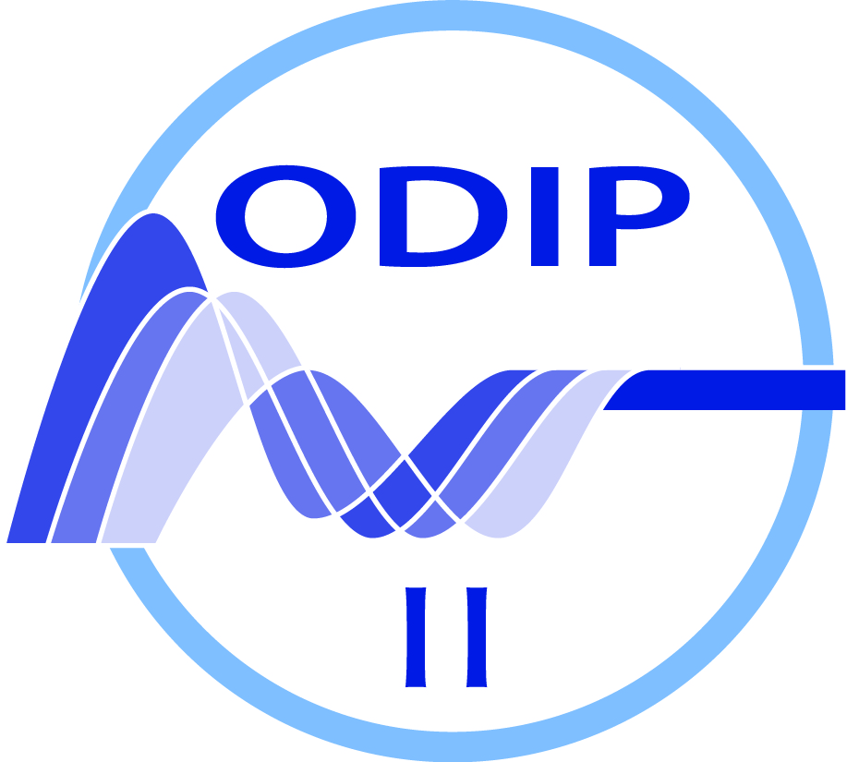

ODIP II workshop

02 May – 05 May 2016

This is the second workshop in the series of four planned for the ODIP II project. The aims of the 2nd ODIP II workshop are 1) assessing the progress that has been made with the development of the existing prototype development tasks including expanding these activities to include additional marine data infrastructures and/or to marine domains; and 2) formulation of additional prototype development tasks as described in the Description of Action (DoA) for the project.

The format of the workshop remains largely the same as that adopted for previous meetings with a mix of plenary, discussion and breakout sessions. The workshop agenda includes a dedicated session for each of the existing prototype development tasks plus additional sessions to introduce some of the new themes and partners added for the ODIP II project.

The three cross-cutting topics that were addressed during the previous ODIP project workshops continue to be relevant for the ODIP II project and will therefore also be included in the workshop programme. These sessions will provide an update on recent developments in these areas and potentially help to identify additional development and collaboration opportunities for the ODIP II project.

Workshop Sessions

Session | Title | Leader
1 | Introduction | Helen Glaves
2 | ODIP Prototype 1 | Dick Schaap
3 | ODIP Prototype 2 | Anne Che-Bohnenstengel
4 | ODIP Prototype 3 | Simon Jirka
5 | Management of marine biology data | TBC
6 | New prototype development activities | Dick Schaap
7 | Data publication, citation and persistent identifiers | Thomas Loubrieu
8 | Model workflows and big data | Adam Leadbetter
9 | Vocabularies/Persistent identifiers | Rob Thomas
10 | Workshop wrap-up | Helen Glaves

Programme

Monday, 02 May 2016

Session 1
8:45 – 9:00 Registration

9:00 – 9:10 Welcome Ben Domenico (UNIDATA)

9:10 – 9:20 Workshop introduction and logistics
Helen Glaves (ODIP project coordinator)

9:20 – 9:35 Introductions
(Name, Country, institution, main responsibility, expectations for this workshop: 30 seconds max.)

ODIP II Overview

9:35 – 9:50 ODIP II: overview of the project including aims and objectives
Helen Glaves (ODIP II Coordinator)

9:50 – 10:05 ODIP II: technical objectives
Dick Schaap (ODIP II Technical Coordinator)

10:05 – 10:20 Discussion

10:20 – 10:45 Break

Session 2

ODIP Prototype Development Task 1: plenary

10:45 – 11:15 ODIP 1: current status and future development activities
Led by Dick Schaap (EU)

11:15 – 12:15 Discussion including other relevant presentations Led by Dick Schaap

12:15 -13:15 Lunch

Session 3

13:15 – 13:30 Ocean Networks Canada Reyna Jenkins (ONC)

ODIP Prototype Development Task 2: plenary

13:30 – 14:00 ODIP 2: current status and future development activities
Led by: Anne Che-Bohnenstengel (BSH)

14:00 – 15:00 Discussion including other relevant presentations
Led by Anne Che-Bohnenstengel (BSH)

15:00 – 15:30 Break

Session 4

ODIP Prototype Development Task 3: plenary

15:30 – 16:15 ODIP 3: current status and future development activities
Led by Simon Jirka

16:15 – 17:00 Discussion and other relevant presentations
Led by Simon Jirka

Tuesday, 03 May 2016

Session 5

Management of marine biology data: plenary
9:00 – 10:45 Introduction to marine biological data management
Led by TBC

10:45 – 11:15 Break

Management of marine biology data: plenary
11:15 – 12:30 Discussion including other relevant presentations Led by TBC

12:30 – 13:30 Lunch

Session 6

ODIP: new development activities: Plenary
13:30 – 14:15 Proposed new ODIP prototype developments
Dick Schaap (ODIP II Technical coordinator)
14:15 – 15:00 Discussion
Led by Dick Schaap

15:00 – 15:30 Break

Session 7

Data publication, citation and persistent identifiers

15:30 – 16:15 Plenary Led by Thomas Loubrieu

RDA Europe data citation implementation pilot study
Thomas Loubrieu
RDA US data citation implementation pilot study
Cyndy Chandler
H2020 THOR project (http://www.project-thor.eu)
TBC

16:15 – 17:00 Discussion Led by Thomas Loubrieu

Wednesday, 04 May 2016

Session 8

Model workflows and big data: plenary

09:00 – 09:45 Model workflows and big data
Led by Adam Leadbetter

09:45 – 10:30 Discussion
Led by Adam Leadbetter

10:30 – 11:00 Break

Model workflows and big data: plenary

11:00 – 12:30 Discussion (cont)
Led by Adam Leadbetter (EU), ?? (USA) & ?? (Australia)

12:30 – 13:30 Lunch

Session 9

Vocabularies

13:30 – 14:15 Plenary
Led by Rob Thomas (BODC)

14:15 – 15:15 Discussion Led by Rob Thomas (BODC)

15:15 – 15:45 Break

Session 10

Breakout sessions

15:45 – 17:00 Vocabularies
Model workflows & big data
Data citation & publication
Sensor web enablement (SWE)

Thursday, 05 May 2016

Session 11

Workshop wrap-up
Workshop session feedback
9:00 – 9:30 Break-out session reports:
1) Vocabularies
2) Data citation/Persistent identifiers
3) Model workflows and big data

9:30 – 10:00 ODIP prototype development projects
Feedback from each group on activities during the workshop and next steps (10 minutes each):

ODIP 1 - Dick Schaap
ODIP 2 – Anne Che-Bohnenstengel
ODIP 3 – Simon Jirka

10:00 – 10:20 Management of marine biology data
Feedback on outcomes from workshop and proposed next actions (TBC)

10:20 – 10:50 Break

10:50 – 11:00 Additional prototype developments
Dick Schaap

11:00 – 11:30 Plans for next 8 months (including status and planning of deliverables)
Helen Glaves (Co-ordinator) /
Dick Schaap (Technical Coordinator)

11.30 – 11.50 Forthcoming dissemination opportunities – discussion
Led by Helen Glaves

11:50 – 12:00 Closing remarks Helen Glaves/Dick Schaap

12:00 – 14:00 Lunch

14:00 – 16:30 ODIP Steering committee meeting (members only)

